# Exercise: Bootstrap Plugins

Problems for exercises and homework for the ["JavaScript For Front-End Course @ SoftUni"](https://softuni.bg/trainings/2032/javascript-for-front-end-july-2018#lesson-8965).

Archive your solutions and upload them on the [course page](https://softuni.bg/trainings/2032/javascript-for-front-end-july-2018#lesson-8969).

## Job Application

You have been tasked to create the following page using [Bootstrap](https://getbootstrap.com/) and the plugins – [Collapse](https://getbootstrap.com/docs/4.1/components/collapse/), [Social Buttons](https://lipis.github.io/bootstrap-social/), [SweetAlert](https://lipis.github.io/bootstrap-sweetalert/) and [Dropify](http://jeremyfagis.github.io/dropify/).

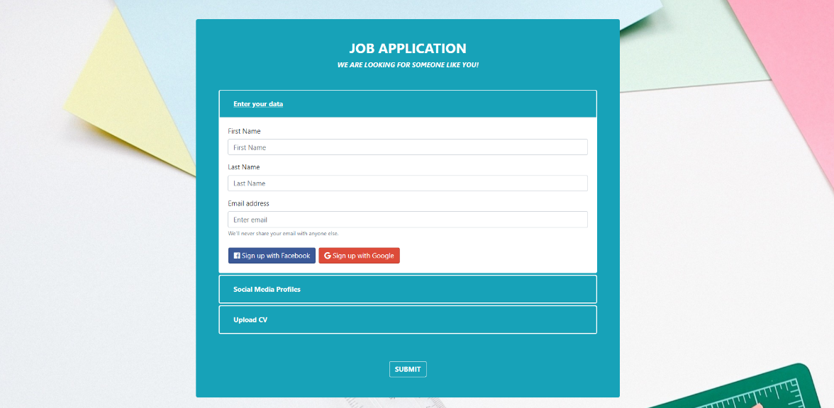

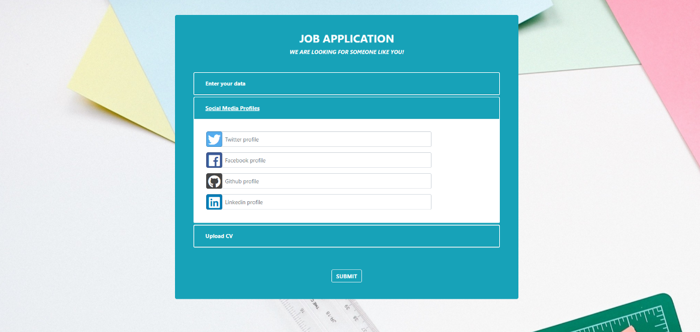

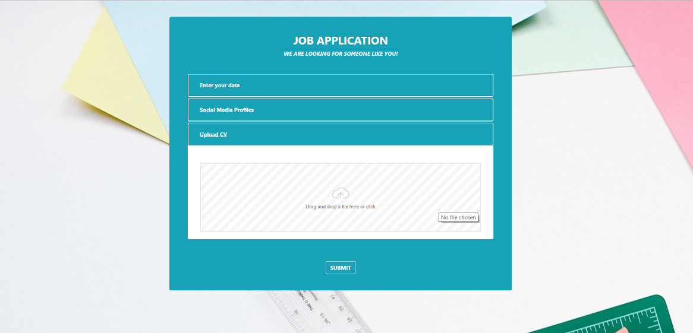

You will be given the **images, text** and **screenshots**.

Your website should have **one page** with a **collapse** **section** and navigation **between** tabs.

### Personal data section

Use [Bootstrap](https://getbootstrap.com/) to create a simple form in the **first section** and add **two** **buttons** for **sign** **up**.   
The **buttons** should be **styled** using the [Social Buttons](https://lipis.github.io/bootstrap-social/) plugin.

Upon **clicking** **one** of them you should **show** a **notification** using the [SweetAlert](https://lipis.github.io/bootstrap-sweetalert/) plugin.

The **first section** should look like this:

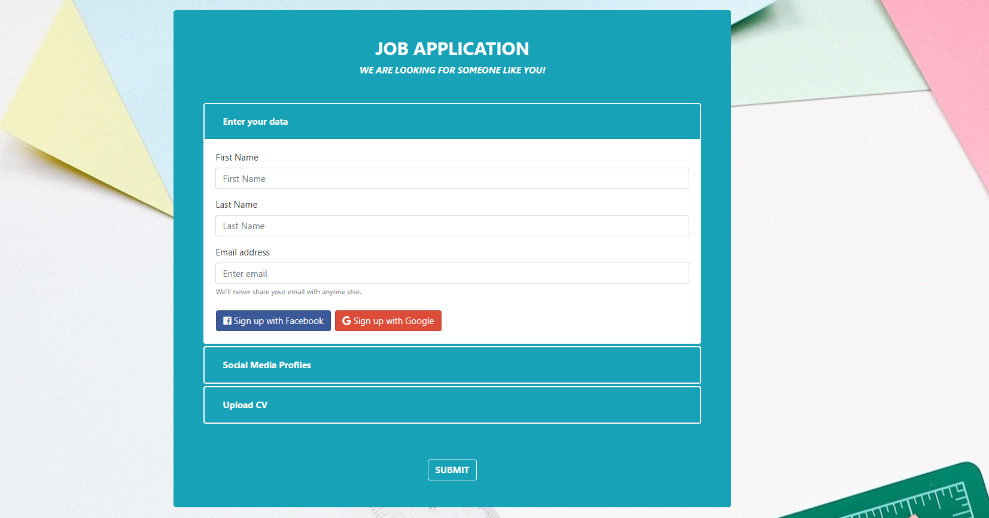

The **notification** you should show upon clicking one of the “social buttons” should look like this:

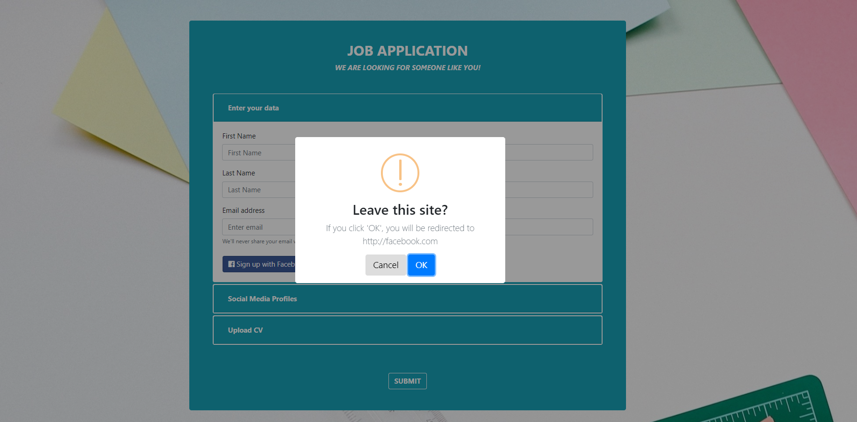

### Social Media Section

This is the **second section**. It should have **4 input fields** for **social media accounts** andtheyshouldbestyledusing the[Social Buttons](https://lipis.github.io/bootstrap-social/) plugin.

The **second** **section** should look like this:

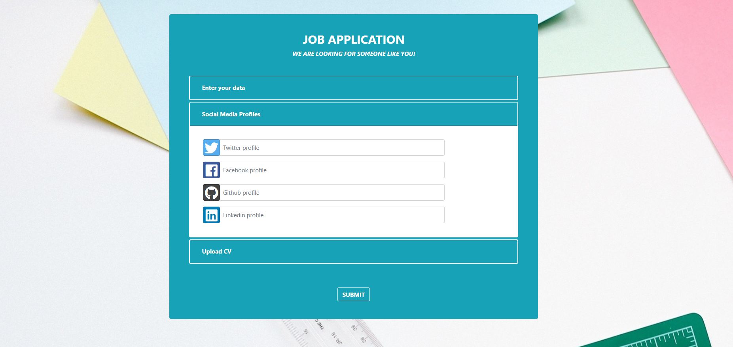

### Upload CV Section

This is the **third section**. It should have a **single input field**, with type – file.   
The **field** should be **styled** using the [Dropify](http://jeremyfagis.github.io/dropify/) plugin.

The **third section** shouldlookslikethis:

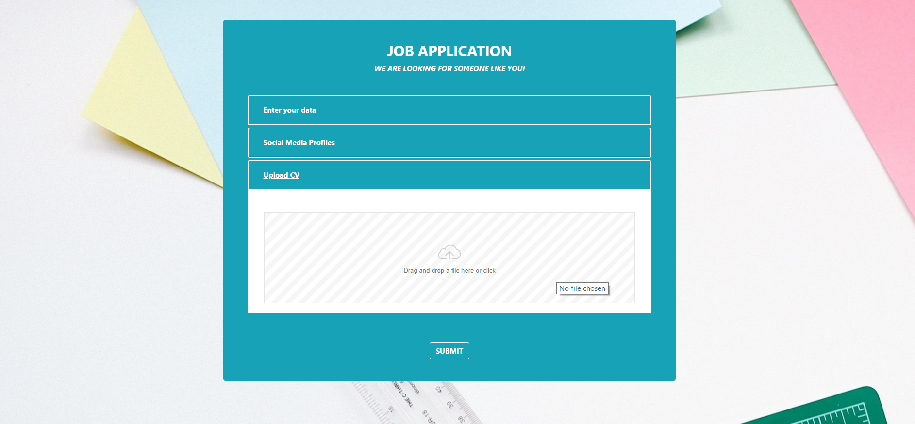

### Submit

Upon clicking the [Submit] button, you should **CLEAR** **all** inputfields and **empty** the Dropify container.